SIMULATION RESULTS

There are two different simulations for R load and RL load; that is, motor. Initially, simulations are observed for R load because practically R load tests are tried before motor tests. In the laboratory, R loads are durable for 3 A so Input peak voltage is 80 V line to line and output current is nearly 3 A at the simulations. Also, duty cycle is 0.7. Also, R is 17.7Ω because in the laboratory, each resistors are 50 Ω and maximum current can be obtained if each load are tied parallel.

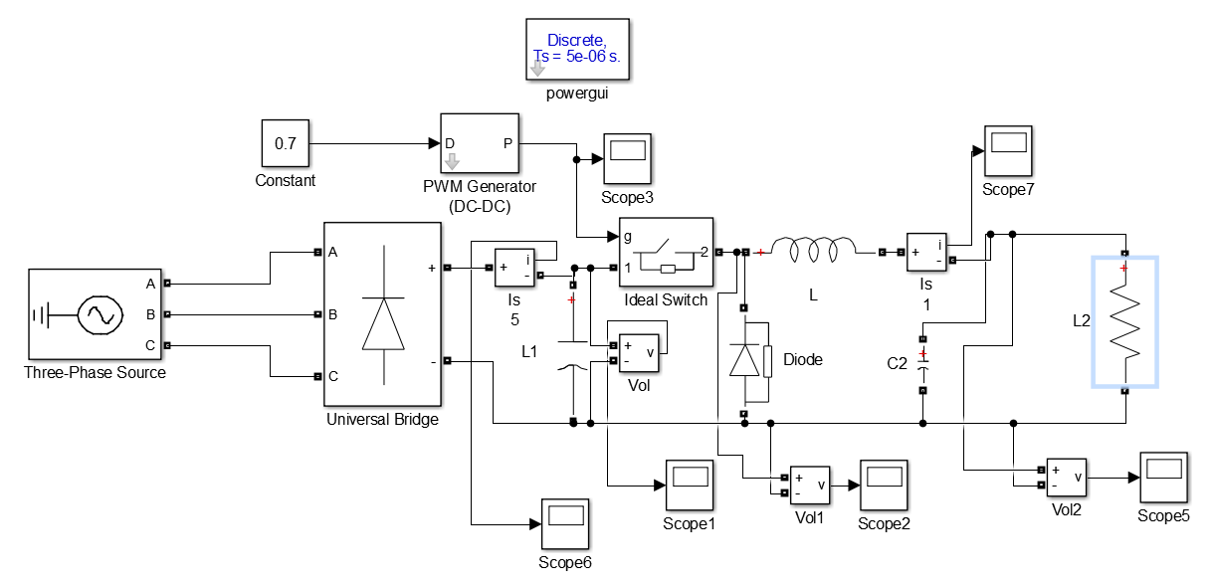

Figure 1: Circuit Schematic with R Load (Without Gate Driver)

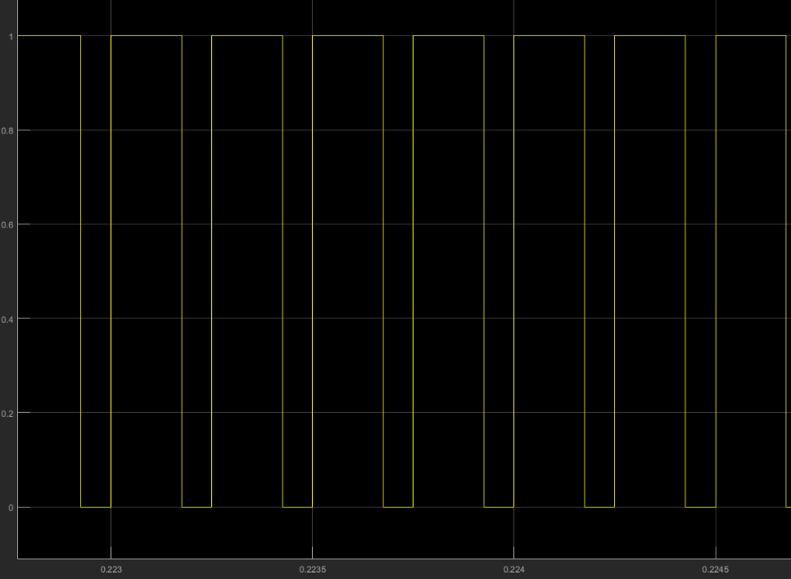

Figure 2: Duty Cycle is 0.7

Duty cycle is 0.7 for all simulation results.

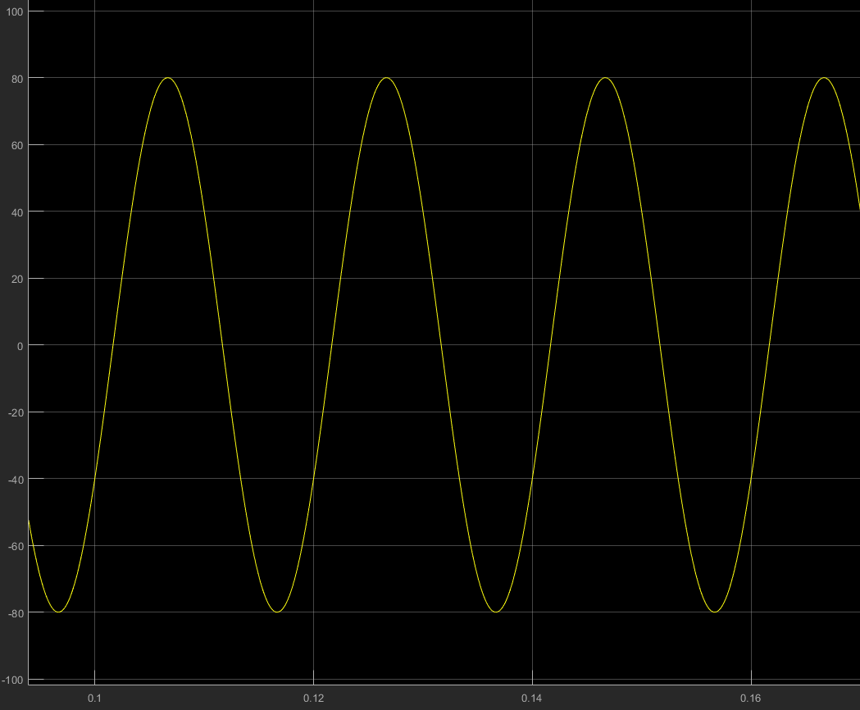

Figure 3: Input Voltage for R load

Input line to line voltage is 80 Vpeak at the simulations for R load.

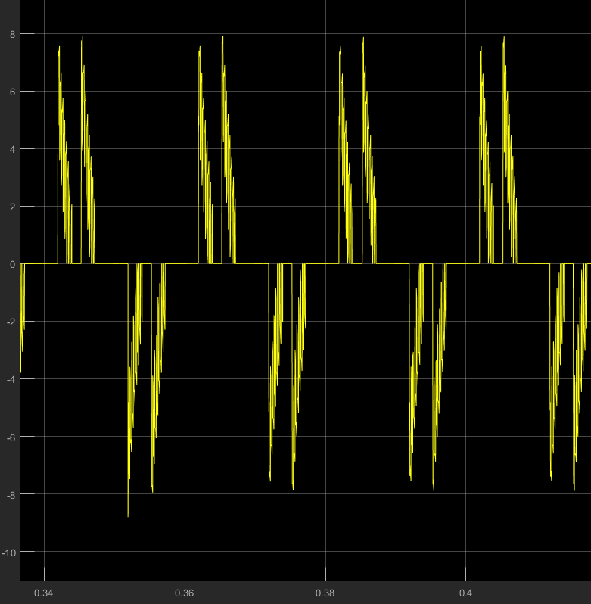

Figure 4: Input Current for R load

There is a capacitor for filtering after three phase diode rectifier. Therefore capacitor try to charge and input current is observed as Figure 4. If there were not a capacitor, third harmonics would disappear and waveform would be similar to sinusoid wave except third harmonics.

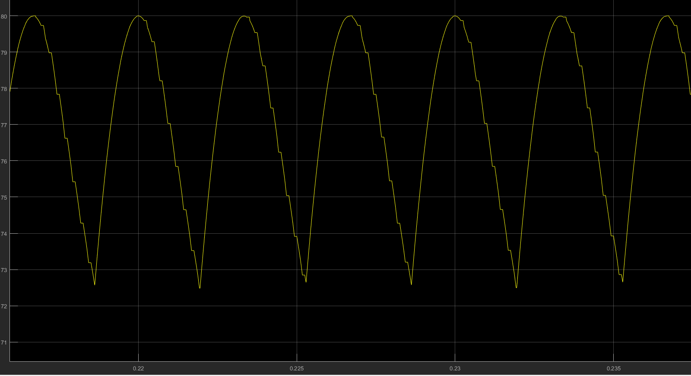

Figure 5: Output of Three Phase Diode Rectifier with 470 uF Capacitor Filter

There is output voltage of three phase diode rectifier at Figure 5. Output voltage have 6 pulse waveform and the frequency is 300 Hz. Also, output ripple is between 73 and 80 V so ripple is 7 V. If there were not a capacitor for filtering, output ripple of three phase diode rectifier would be 11 V.

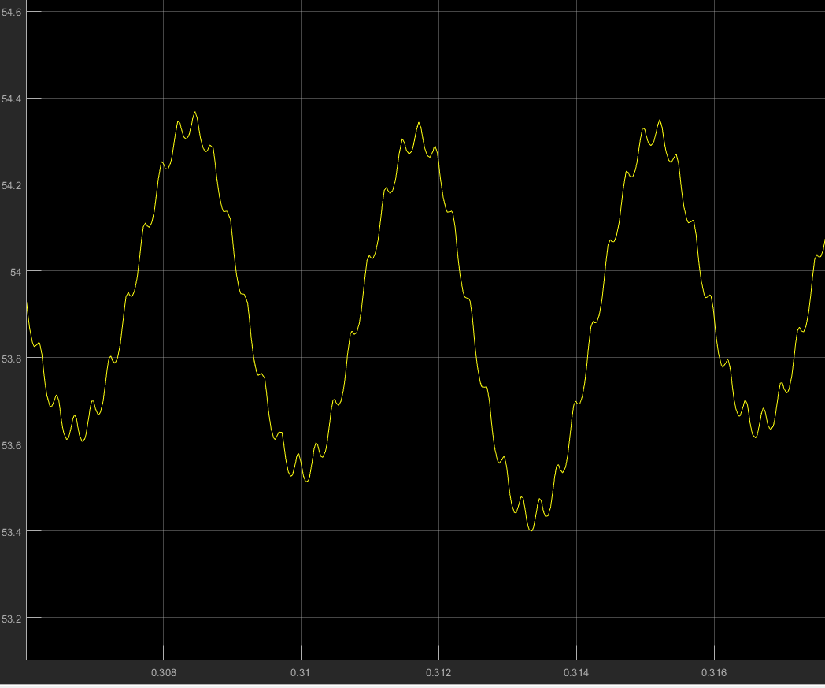

Figure 6: Output Voltage for R Load

After the output of the three phase diode rectifier, buck converter is used and output voltage ripple is observed as Figure 6 from the simulation. At the buck converter side 680 uF capacitor and 2.8 mH inductor are used and ripple is nearly 1 V. If capacitor value is increased, the ripple will decrease.

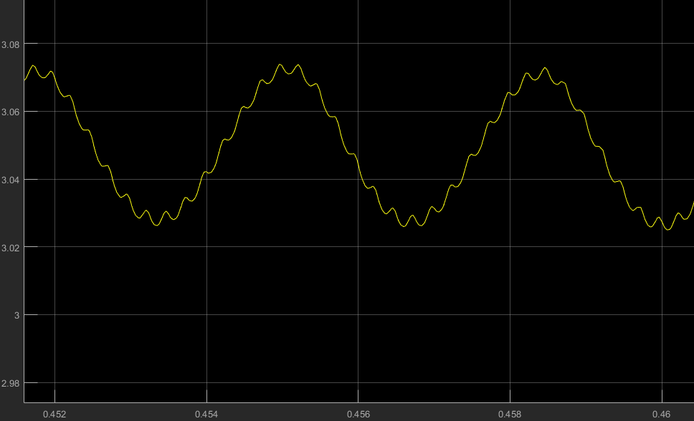

Figure 7: Output Current for R Load

There is an R load so Output current and output voltage have similar waveform because

$$Voltage=Current*Resistor$$

Therefore, output ripple has almost DC characteristic and ripple is decreased if capacitance is increased.

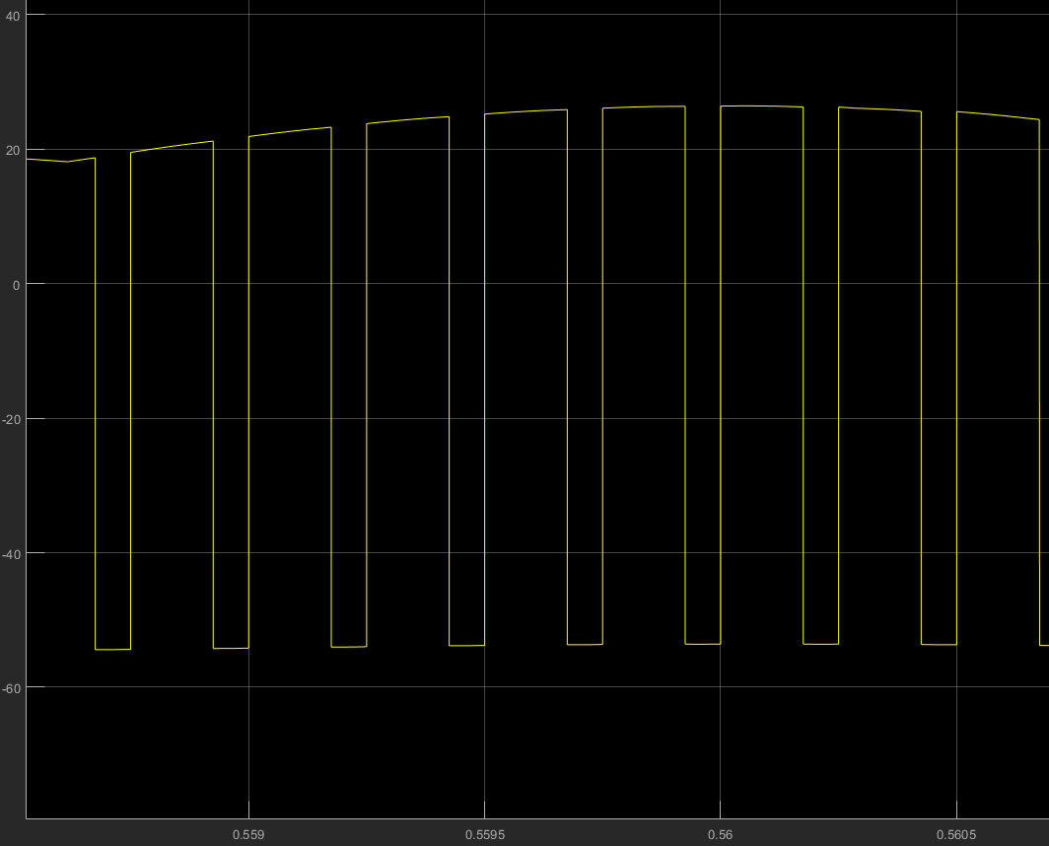

Figure 8: Inductor Voltage for R load

Inductor voltage has Vd-Vo value for switch ON state and it has –Vo value for switch OFF state. Also, continuous conduction mode is observed from the simulation for 4 kHz switching frequency.

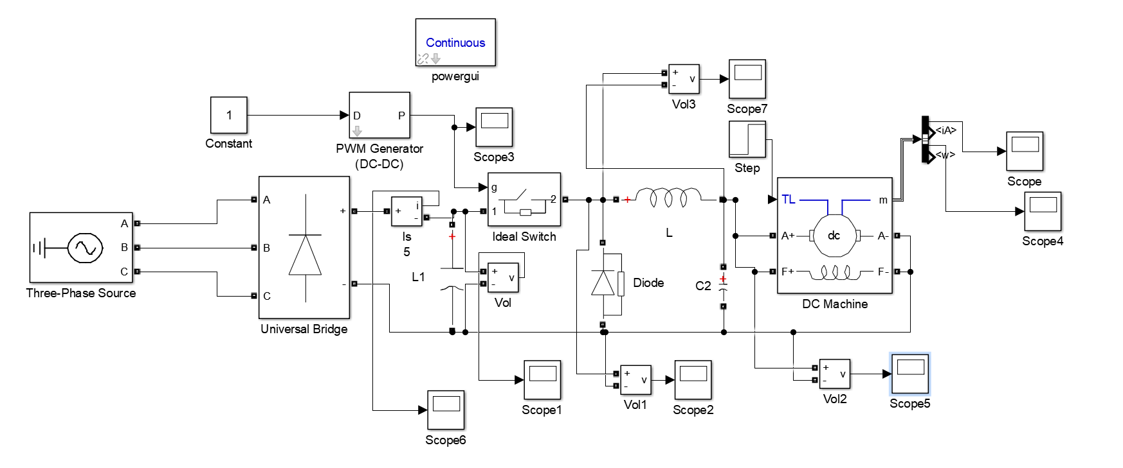

Figure 9: Circuit Schematic with DC Motor (Without Gate Driver)

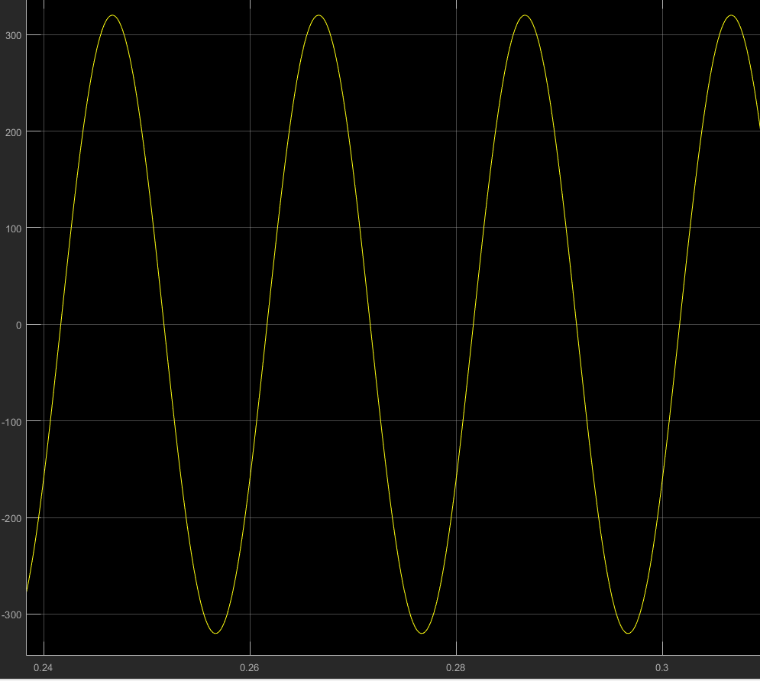

Figure 10: Input Voltage Waveform for 320 Vpeak line to line

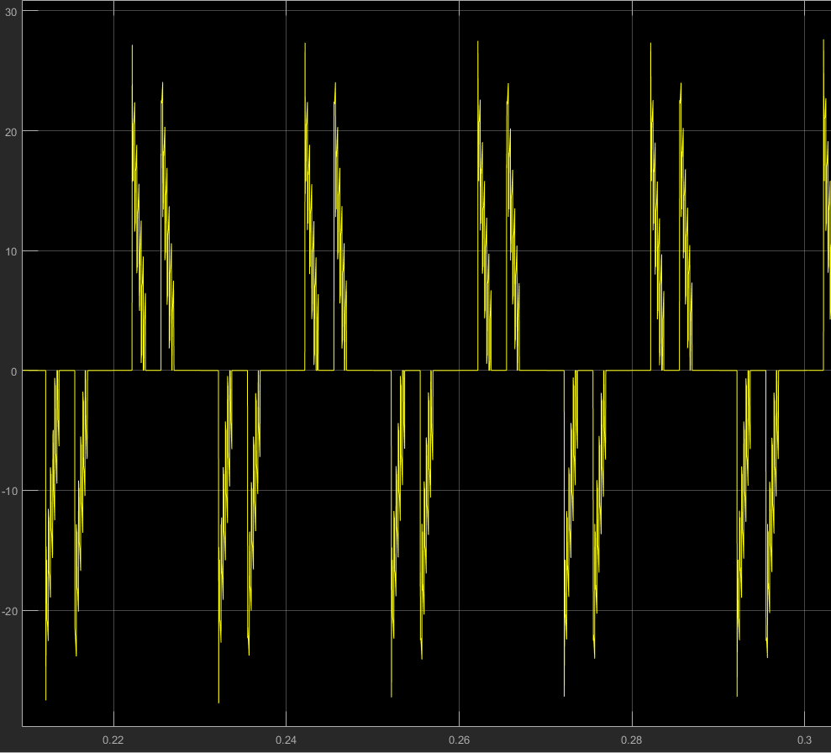

Figure 11: Input Current Waveform for 320 Vpeak line to line

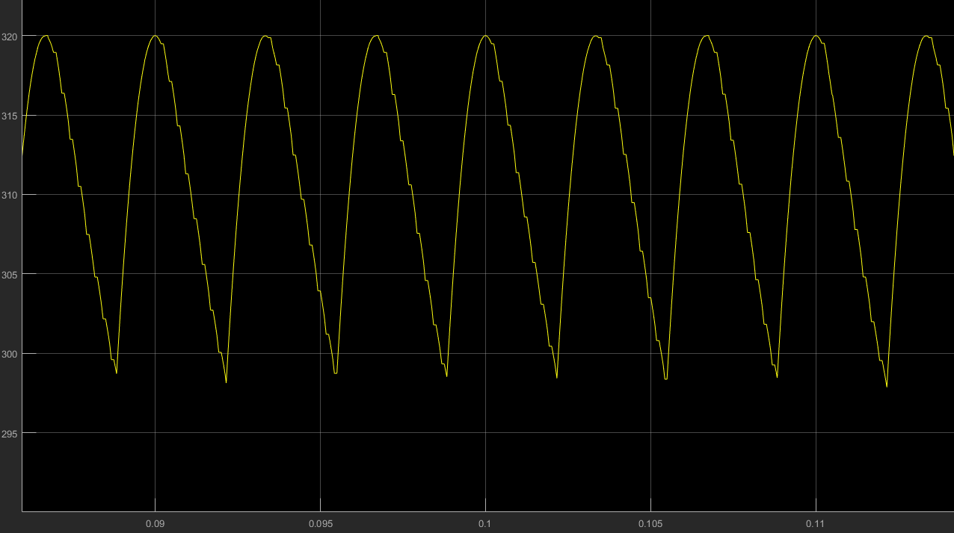

Figure 12: Output Voltage of 3 Phase Rectifier After 470 uF Capacitor Filter

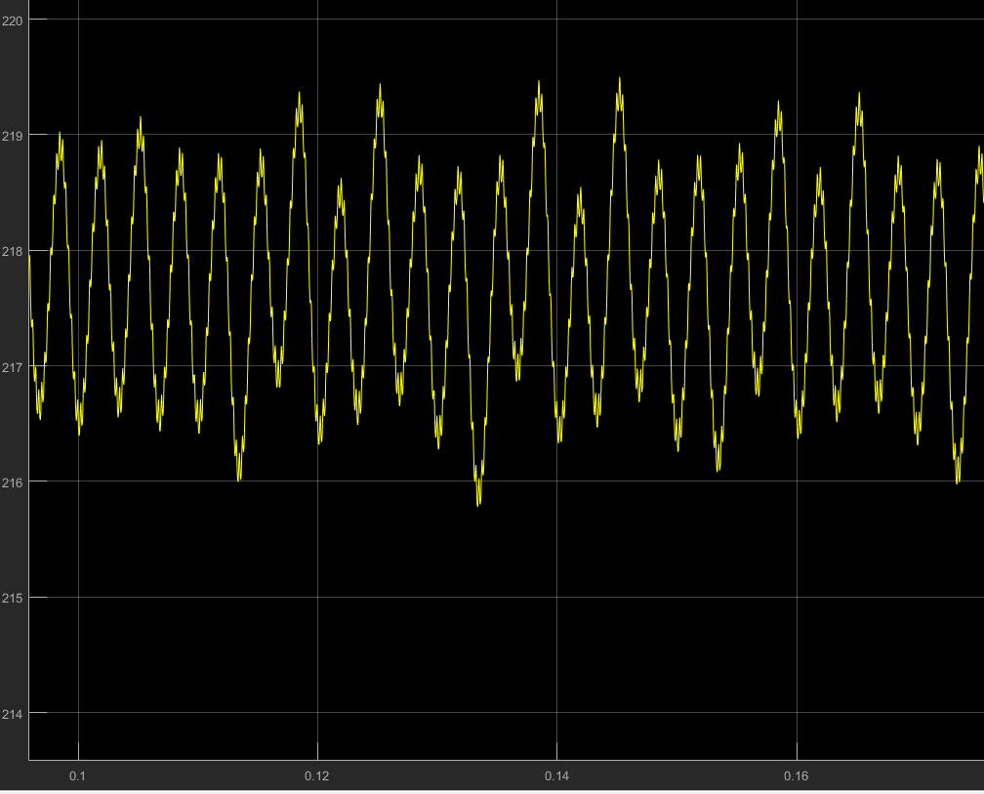

Figure 13: Output Voltage when D=0.7 and input voltage 320 Vline

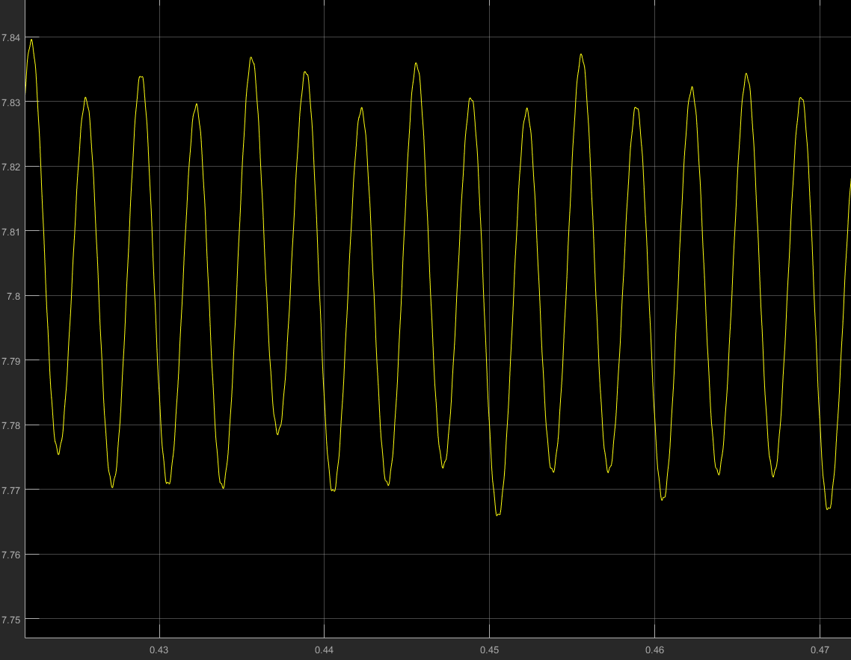

Figure 14: Output current when D=0.7 and input voltage 320 Vline

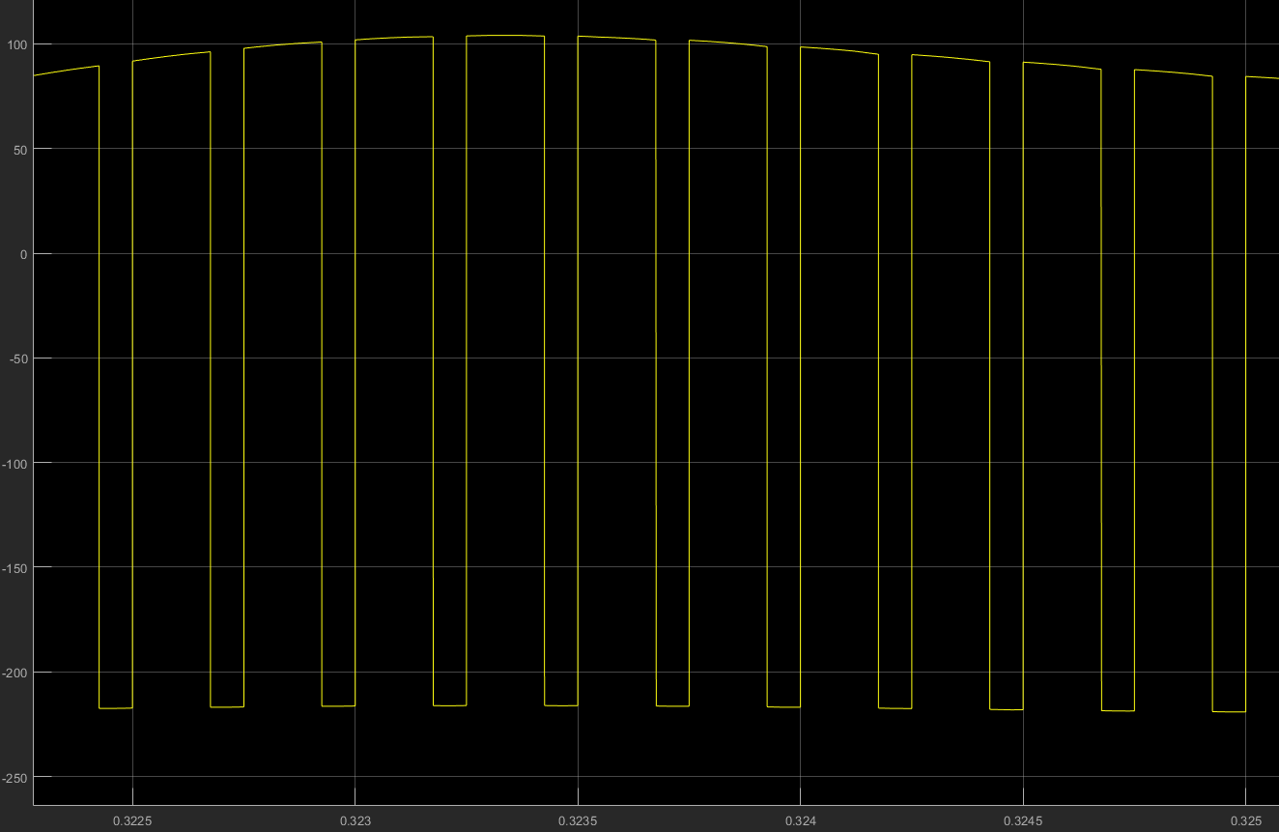

Figure 15: Inductor voltage when D=0.7 and input voltage 320 V (line to line)